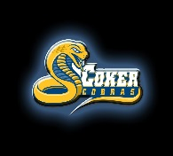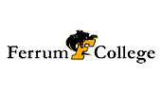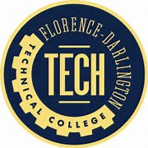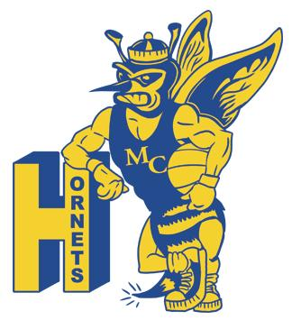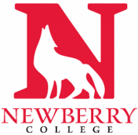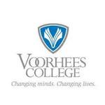

DILLON HIGH SCHOOL
2018 SENIOR COLLEGE ACCEPTANCE LIST

Coker College | Jasia Murray
Ferrum College | Maya McLellan
Florence- Darlington Technical College | Megan Johnson  Lanajia Page  Johnny Ramirez  Franco Rodriguez  Brandi Turner
Morris College | Diamond Green  Khadijah Purnell
Newberry College | Jasia Murray
Voorhees College | Zakarrius Hayes  Jada Lytch

